DoDAF 2.0 Architectural Models-Views and Descriptions

Models | Descriptions
AV-1: Overview and Summary Information | Describes a Project's Visions, Goals, Objectives, Plans, Activities, Events, Conditions, Measures, Effects (Outcomes), and produced objects.
AV-2: Integrated Dictionary | An architectural data repository with definitions of all terms used throughout the architectural data and presentations.
CV-1: Vision | The overall vision for transformational endeavors, which provides a strategic context for the capabilities described and a high-level scope.
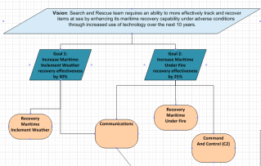 | - The CV-1 text describes a Vision, Capability (over a bounded period of time), Goals (with the desired outcomes and measureable benefits), Strategy.  - This diagram is meant to capture the relationship between the Vision, the Goals and the Capabilities. It is a decomposition type of a diagram. In this example there is one Vision, two Goals and four Capabilities.
CV-2: Capability Taxonomy | A hierarchy of capabilities which specifies all the capabilities that are referenced throughout one or more Architectural Descriptions.
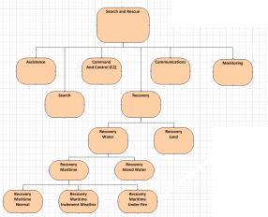 | - The CV-2 is a parent-child (sub-super type) relationship between Capabilities. A hierarchal diagram is most often used to show this relationship.  - This diagram is meant to capture this relationship. A Capability should be different that an activity.
CV-3: Capability Phasing | The planned achievement of capability at different points in time or during specific periods of time. The CV-3 shows the capability phasing in terms of the activities, conditions, desired effects, rules complied with, resource consumption and production, and measures, without regard to the performer and location solutions.
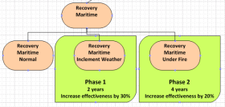 | - The CV-3 provides a representation of the available capability at different points in time.  - This diagram is meant to capture the time phase of the second and third child capability through the green shape which carries the phase data. Other techniques may be used to capture the phase data as desired.
CV-4: Capability Dependencies | The dependencies between planned capabilities and the definition of logical groupings of capabilities.
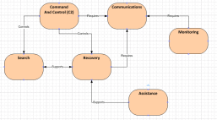 | - The CV-4 describes the dependencies between planned capabilities.  - This diagram shows relationships (including a relationship label) between six capabilities.
CV-5: Capability to Organizational Development Mapping | The fulfillment of capability requirements shows the planned capability deployment and interconnection for a particular Capability Phase. The CV-5 shows the planned solution for the phase in terms of performers and locations and their associated concepts.
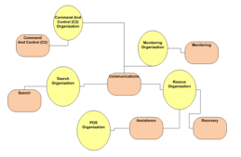 | - The CV-5 shows deployment of Capabilities to specific organizations.  - This diagram shows the relationship between Capability and Organizations
CV-6: Capability to Operational Activities Mapping | A mapping between the capabilities required and the operational activities that those capabilities support.
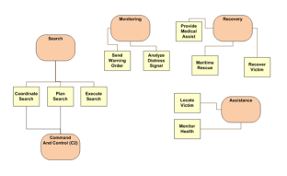 | - A mapping between the capabilities required and the operational activities that those capabilities support.  - This diagram shows the relationship between Capability and Activities. Either style of presentation is acceptable for this model, a graphical mapping or a matrix mapping.
CV-7: Capability to Services Mapping | A mapping between the capabilities and the services that these capabilities enable.
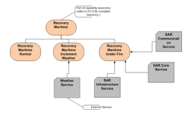 | - The CV-7 describes the mapping between the capabilities required and the services that enable those capabilities.  - This diagram shows the relationship between Capability and Activities. Either style of presentation is acceptable for this model, a graphical mapping or a matrix mapping.
DIV-1:Conceptual Data Model | The required high-level data concepts and their relationships.
DIV-2: Logical Data Model | The documentation of the data requirements and structural business process (activity) rules. In DoDAF V1.5, this was the OV-7.
DIV-3: Physical Data Model | The physical implementation format of the Logical Data Model entities, e.g., message formats, file structures, physical schema. In DoDAF V1.5, this was the SV-11.
OV-1: High-Level Operational Concept Graphic | The high-level graphical/textual description of the operational concept.
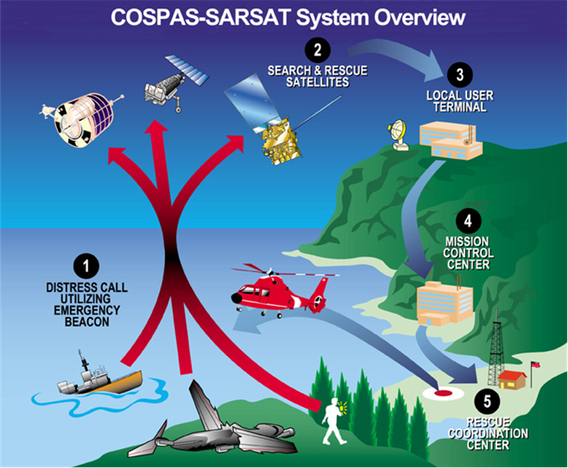 | - The OV-1 is the pictorial representation of the written content of the AV-1 Overview and Summary Information.  - This diagram is meant to convey the general, high level, description of the systems that may perform in this mission, and that there may be some form of communication between them. This is a pictorial representation only.
OV-2: Operational Resource Flow Description | A description of the Resource Flows exchanged between operational activities.
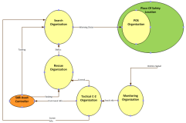 | - The OV-2 depicts Operational Needlines that indicate a need to exchange resources. The OV-2 is intended to track the need for Resource Flows between specific Operational Activities and Locations that play a key role in the Architectural Description  - This diagram is meant to capture the needlines between the different Organizations [Locations] that are key to this sample architecture description.
OV-3: Operational Resource Flow Matrix | A description of the resources exchanged and the relevant attributes of the exchanges.
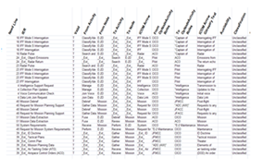 | - The OV-3 identifies resource elements and relevant attributes of the Resource Flows and associates the exchange to the producing and consuming Operational Activities and locations and to the Needline that the Resource Flow satisfies.  - This matrix is a list of Resource Flows and the key attributes of the associated Resources. One or more rows of this matrix are associated with a Needline in the OV-2: Operational Resource Flow Description.
OV-4: Organizational Relationships Chart | The organizational context, role or other relationships among organizations.
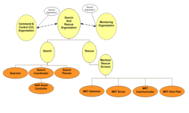 | - The OV-4 addresses the organizational aspects of an Architectural Description.  - This diagram is meant to show the hierarchical relationships between the organizations involved in Search and Rescue.
OV-5a: Operational Activity Decomposition Tree | The capabilities and activities (operational activities) organized in a hierarchal structure.
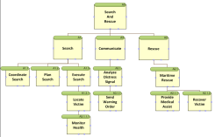 | - The OV-5a helps provide an overall picture of the activities involved and a quick reference for navigating the OV-5b.  - This diagram shows the hierarchical representation of the Search and Rescue activities. These will be used in the OV-5b Operational Activity Model
OV-5b: Operational Activity Model | The context of capabilities and activities (operational activities) and their relationships among activities, inputs, and outputs; Additional data can show cost, performers, or other pertinent information.
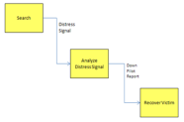 | - The Activity Model shows activities connected by Resource Flows; it supports development of an OV-3 Operational Resource Flow Matrix.  - This diagram shows an example of Operational Activities that produce and consume Resource Flows. These Resource Flows and related Operational Activities are related to the Resource Flows identified in both the OV-2 Operational Resource Flow Description and the OV-3 Operational Resource Flow Matrix.
OV-6a: Operational Rules Model | One of three models used to describe activity (operational activity). It identifies business rules that constrain operations.
OV-6b: State Transition Description | One of three models used to describe operational activity (activity). It identifies business process (activity) responses to events (usually, very short activities).
OV-6c: Event-Trace Description | One of three models used to describe activity (operational activity). It traces actions in a scenario or sequence of events.
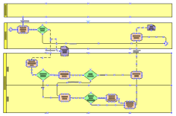 | - The OV-6c provides a time-ordered examination of the Resource Flows as a result of a particular scenario.  - This diagram is meant to show the sequence of activities and the data that flows between them. The lanes in this diagram are the Organizations that are used in the OV-2 Operational Resource Flow Diagram.
PV-1: Project Portfolio Relationships | It describes the dependency relationships between the organizations and projects and the organizational structures needed to manage a portfolio of projects.
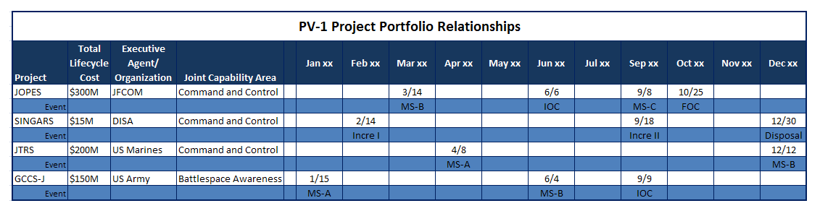 | - The PV-1 describes how acquisition projects are grouped in organizational terms as a coherent portfolio of acquisition programs or projects, or initiatives related to several portfolios.  - This diagram is meant to show Programs and how they are organized by increment, JCAs and total cost.
PV-2: Project Timelines | A timeline perspective on programs or projects, with the key milestones and interdependencies.
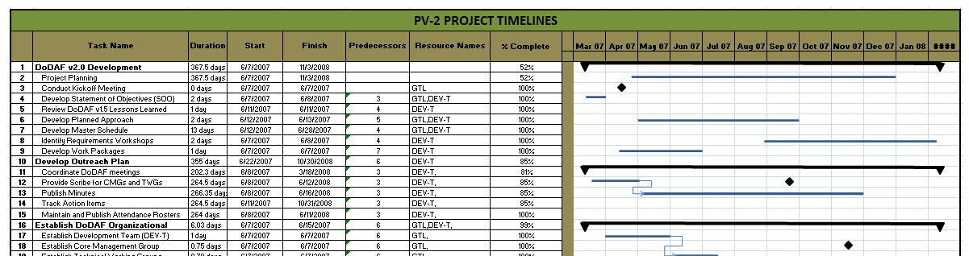 | - The PV-2 provides an overview of a program or portfolio of individual projects, or initiatives, based on a timeline.  - This diagram is meant to show Programs and how they are organized on a timeline.
PV-3: Project to Capability Mapping | A mapping of programs and projects to capabilities to show how the specific projects and program elements help to achieve a capability.
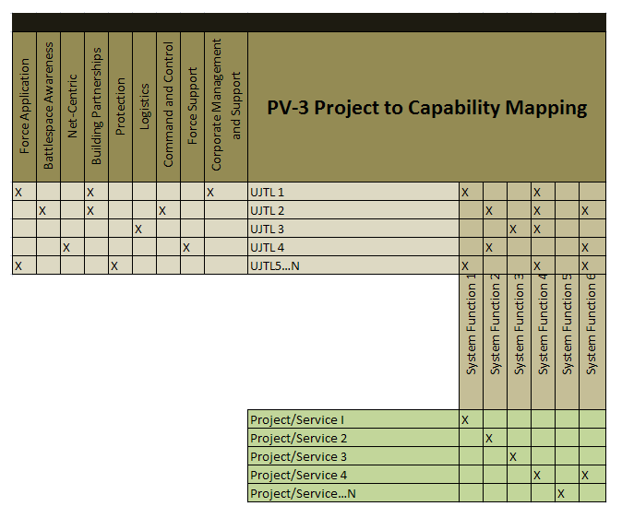 | - The PV-2 provides an overview of a program or portfolio of individual projects, or initiatives, based on a timeline.  - This diagram is meant to the mapping of Projects to the Capability by tracing through the dependent relationship. This shows the relationship is not direct but dependent on other relationships.
SvcV-1 Services Context Description | The identification of services, service items, and their interconnections.
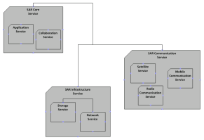 | - The SvcV-1 addresses the composition and interaction of Services. A SvcV-1 can be used simply to depict services and sub-services and identify the Resource Flows between them  - This diagram is meant to show the Resource Flow between the Services used in the Search and Rescue architecture description.
SvcV-2 Services Resource Flow Description | A description of Resource Flows exchanged between services.
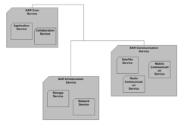 | - A SvcV-2 DoDAF-described Model is used to give a precise specification of a connection between Services.  - This diagram depicts the physical connectivity between the Services supporting the Resource Flows identified in the SvcV-1 diagram.
SvcV-3a Systems-Services Matrix | The relationships among or between systems and services in a given Architectural Description.
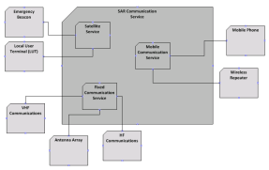 | - A SvcV-3a enables a quick overview of all the system-to-service resource interactions specified in one or more SvcV-1 Services Context Description models.  - This diagram depicts the system to service dependencies.
SvcV-3b Services-Services Matrix | The relationships among services in a given Architectural Description. It can be designed to show relationships of interest, (e.g., service-type interfaces, planned vs. existing interfaces).
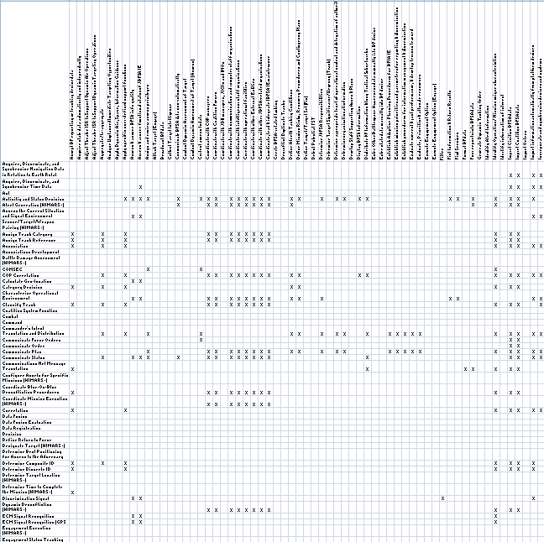 | - The SvcV-3b provides a tabular summary of the services interactions specified in the SvcV-1 Services Context Description for the Architectural Description.  - This diagram depicts the Service to Service interactions in a matrix format.
SvcV-4 Services Functionality Description | The functions performed by services and the service data flows among service functions (activities).
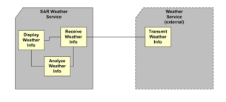 | - The primary purpose of SvcV-4 is to develop a clear description of the necessary data flows that are input (consumed) by and output (produced) by each resource.  - This diagram depicts the data flows that flow between the services of the architecture.
SvcV-5 Operational Activity to Services Traceability Matrix | A mapping of services (activities) back to operational activities (activities).
- The SvcV-5 depicts the mapping of service functions to operational activities and thus identifies the transformation of an operational need into a purposeful action performed by a service solution.
- This matrix depicts the relationships between the set of Operational Activities and the set of Service Functions applicable to an Architectural Description
SvcV-6 Services Resource Flow Matrix | It provides details of service Resource Flow elements being exchanged between services and the attributes of that exchange.
- The SvcV-6 specifies the characteristics of the Service Resource Flows exchanged between Services.
- The SvcV-6 identifies resource elements and relevant attributes of the Resource Flows and associates the exchange to the producing and consuming Services.
This matrix is a list of Resource Flows and the key attributes of the associated Resources.
SvcV-7 Services Measures Matrix | The measures (metrics) of Services Model elements for the appropriate time frame(s).
SvcV-8 Services Evolution Description | The planned incremental steps toward migrating a suite of services to a more efficient suite or toward evolving current services to a future implementation.
SvcV-9 Services Technology & Skills Forecast | The emerging technologies, software/hardware products, and skills that are expected to be available in a given set of time frames and that will affect future service development.
SvcV-10a Services Rules Model | One of three models used to describe service functionality. It identifies constraints that are imposed on systems functionality due to some aspect of system design or implementation.
SvcV-10b Services State Transition Description | One of three models used to describe service functionality. It identifies responses of services to events.
SvcV-10c Services Event-Trace Description | One of three models used to describe service functionality. It identifies service-specific refinements of critical sequences of events described in the Operational Viewpoint.
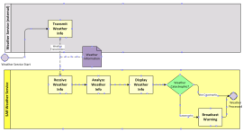 | - The SV-10c provides a time-ordered examination of the Resource Flows as a result of a particular scenario.  - This diagram is meant to show the sequence of System Function (activities) and the data that flows between them. The lanes in this diagram are the Organizations that are used in the SV-1 Operational Resource Flow Diagram.
StdV-1 Standards Profile | The listing of standards that apply to solution elements.
StdV-2 Standards Forecast | The description of emerging standards and potential impact on current solution elements, within a set of time frames.
SV-1 Systems Interface Description | The identification of systems, system items, and their interconnections.
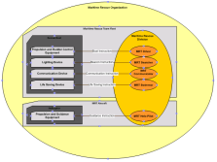 | - The SV-1 depicts all System Resource Flows between Systems that are of interest.  - This diagram is meant to show the Resource Flows between a Person Type and a System (both are types of Performer). The diagram also shows the grouping of Performer Types.
SV-2 Systems Resource Flow Description | A description of Resource Flows exchanged between systems.
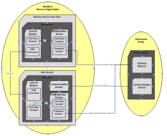 | - A SV-2 DoDAF-described Model is used to give a precise specification of a connection between Systems. This may be an existing connection, or a specification for a connection that is to be made.  - This diagram is meant to show a representation of the primary physical connection between the systems of interest.
SV-3 Systems-Systems Matrix | The relationships among systems in a given Architectural Description. It can be designed to show relationships of interest, (e.g., system-type interfaces, planned vs. existing interfaces).
- The SV-3 provides a tabular summary of the system interactions specified in the SV-1 Systems Interface Description model for the Architectural Description.
- This matrix is used to identify the association between Systems in context with the architecture’s purpose.
SV-4 Systems Functionality Description | The functions (activities) performed by systems and the system data flows among system functions (activities).
SV-5a Operational Activity to Systems Function Traceability Matrix | A mapping of system functions (activities) back to operational activities (activities).
- The SV-5a addresses the linkage between System Functions described in SV-4 Systems Functionality Description and Operational Activities specified in OV-5a Operational Activity Decomposition Tree or OV-5b Operational Activity Model.
- This matrix is used to tie together the logical representation of the Operational Activities of the OV-5a with the System Functions of the SV-4 Systems Functionality Description.
SV-5b Operational Activity to Systems Traceability Matrix | A mapping of systems back to capabilities or operational activities (activities).
SV-6 Systems Resource Flow Matrix | Provides details of system resource flow elements being exchanged between systems and the attributes of that exchange.
- The SV-6 focuses on the specific aspects of the system Resource Flow and the system Resource Flow content in a tabular format.
- The SV-6 identifies resource elements and relevant attributes of the Resource Flows and associates the exchange to the producing and consuming Systems
This matrix is a list of Resource Flows and the key attributes of the associated Resources.
SV-7 Systems Measures Matrix | The measures (metrics) of Systems Model elements for the appropriate timeframe(s).
SV-8 Systems Evolution Description | The planned incremental steps toward migrating a suite of systems to a more efficient suite, or toward evolving a current system to a future implementation.
SV-9 Systems Technology & Skills Forecast | The emerging technologies, software/hardware products, and skills that are expected to be available in a given set of time frames and that will affect future system development.
SV-10a Systems Rules Model | One of three models used to describe system functionality. It identifies constraints that are imposed on systems functionality due to some aspect of system design or implementation.
SV-10b Systems State Transition Description | One of three models used to describe system functionality. It identifies responses of systems to events.
SV-10c Systems Event-Trace Description | One of three models used to describe system functionality. It identifies system-specific refinements of critical sequences of events described in the Operational Viewpoint.
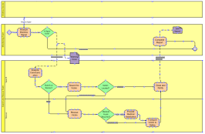 | - The SV-10c provides a time-ordered examination of the Resource Flows as a result of a particular scenario.  - This diagram is meant to show the sequence of System Function (activities) and the data that flows between them. The lanes in this diagram are the Organizations that are used in the SV-1 System Resource Flow Diagram.

